Typescript Fundamentals

What is TypeScript?
----------------------------------------------------------------

Introduction
TypeScript is an open-source programming language developed by Microsoft built on top of JavaScript by adding static typing. In simple terms, its JavaScript with extra features that help catch errors early and make your code easier to understand and code.
TypeScript files have .ts extension and are compiles down to regular JavaScript that browsers and Node.js can run.

Example of JavaScript
In JS we don’t need to define datatype of a,b in add function and we can pass any datatype while calling the add method.
If there is an error, it would be reported at runtime.
function add(a,b){
return a + b;
}
add(8,10)//18
add(8,”10”)//810

Example of TypeScript
In TS we define the datatype for a,b in add function. If we pass incorrect data type value like(instead of int we pass a string) while calling the add method , error will be reported at compile time itself.
Early error detection.
function add (a: number, b: number){
return a + b;
}
add(8,10)//18
add(8,”10”)//error reported at compile time itself.

Prerequisite
1. Install Nodejs
2. IDE – Visual Studio Code
3. Install TypeScript globally
4. ts-node

Install Node.js
Goto https://nodejs.org/en/download and download the nodejs based on OS.
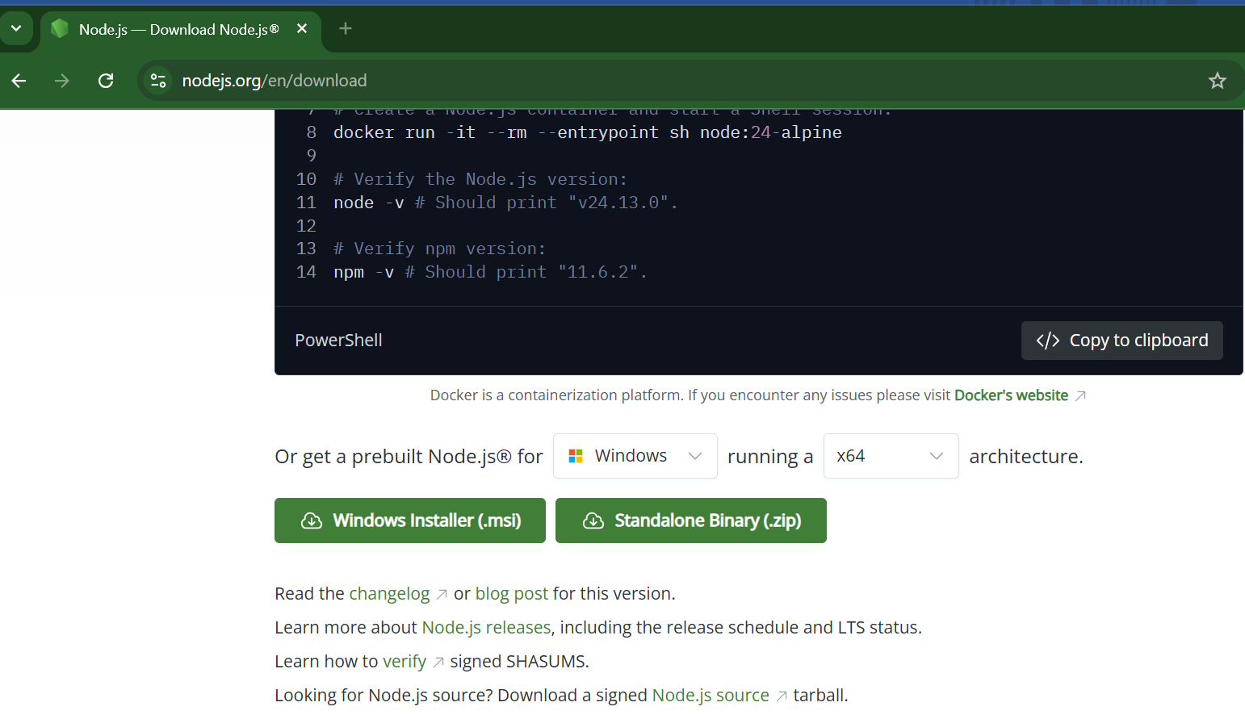
Once installed verify the node and npm version:
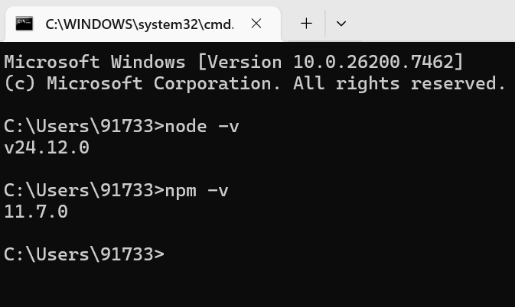

Download Visual Studio
Go to https://code.visualstudio.com/download and download VS code based on OS version
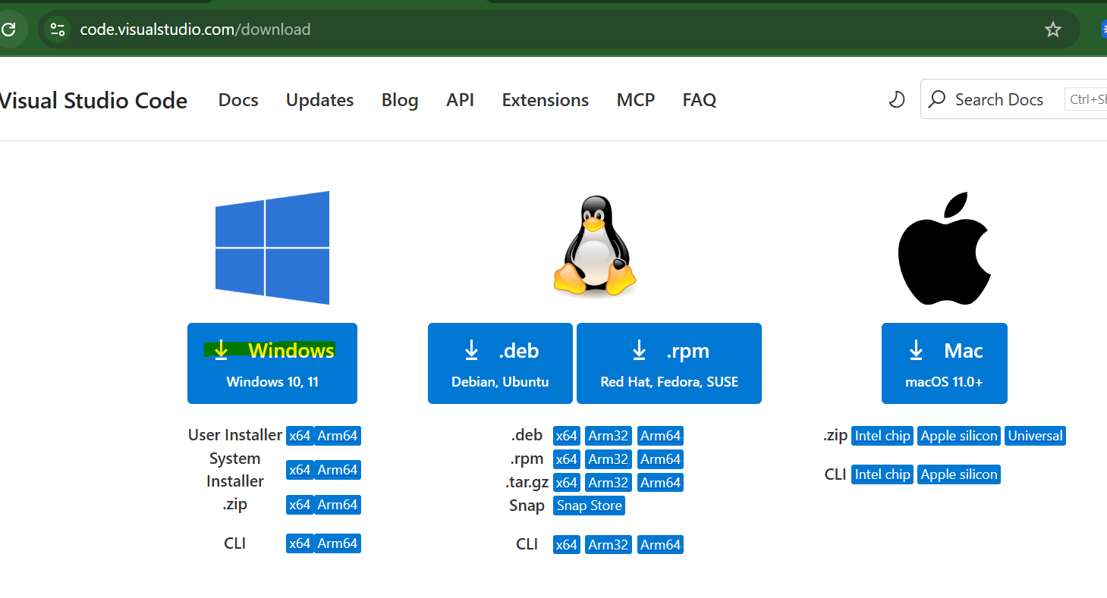
File > New Window
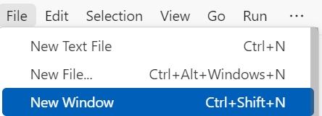
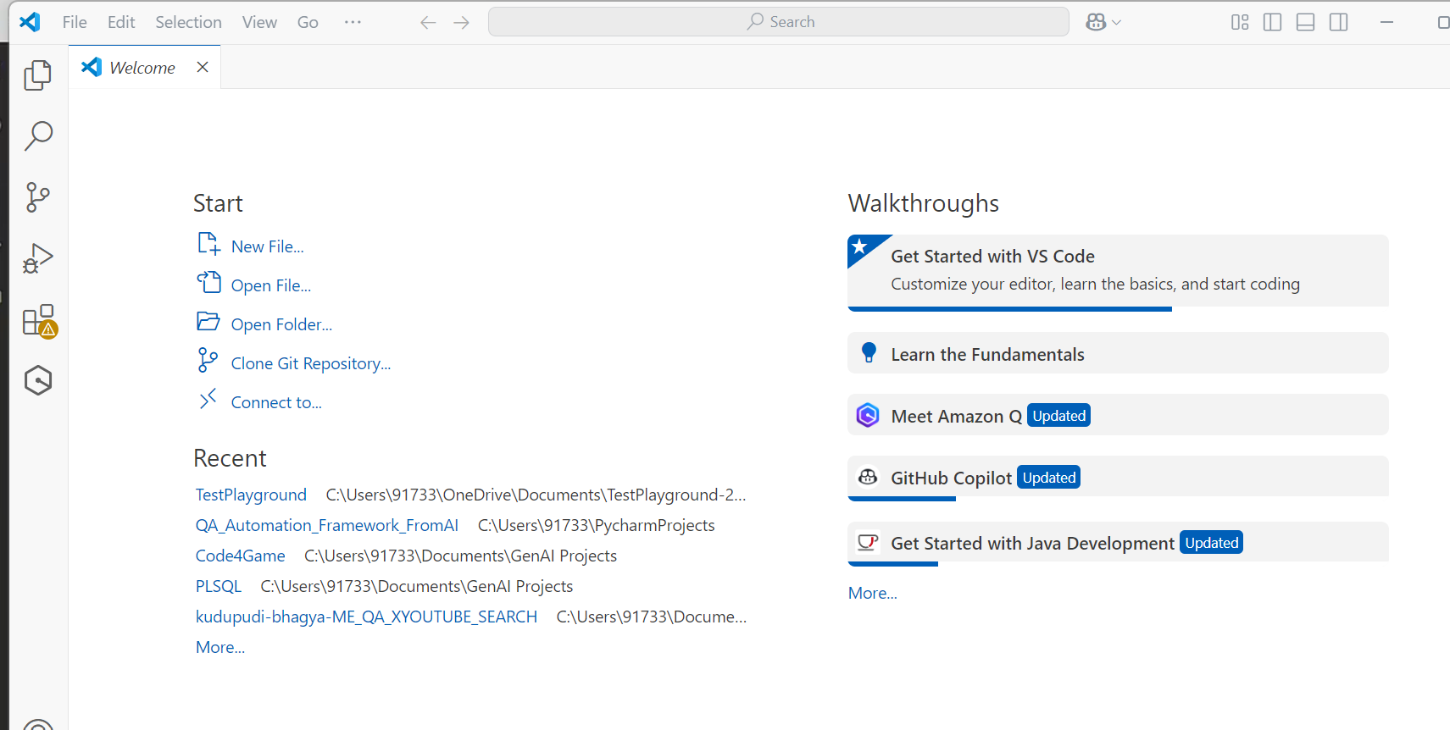

Install TypeScript
View > Terminal and we have to install type script
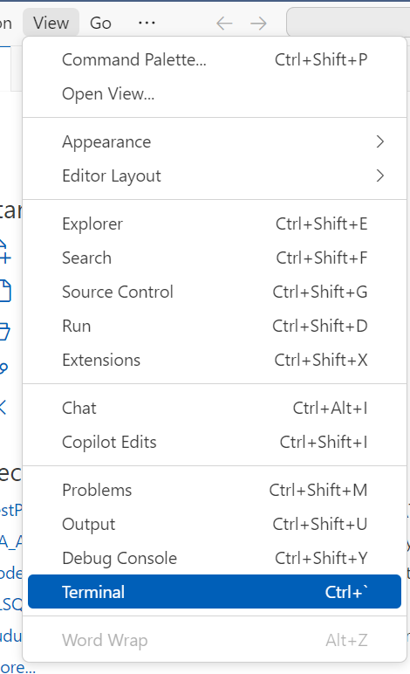
npm install -g typescript
>To check current version of typescript, In VS Code Terminal:
tsc --version
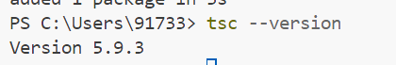

Incase of error:
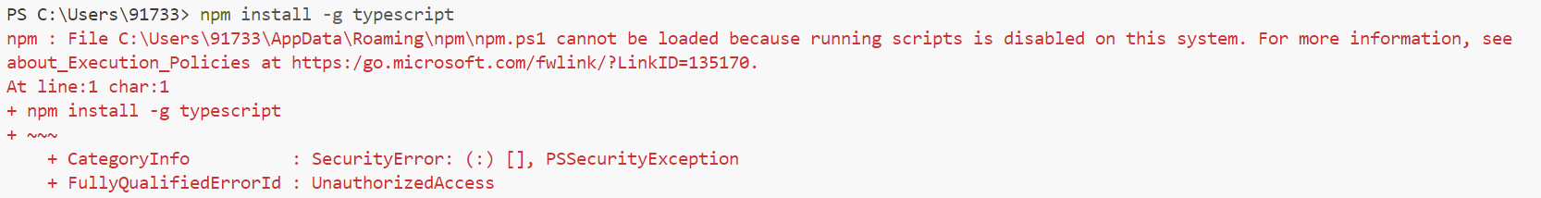
Steps to Resolve
- Open PowerShell as Administrator
- Press Win + X → choose Windows PowerShell (Admin) or Terminal (Admin).
- Check Current Execution Policy
Get-ExecutionPolicy
- If it shows Restricted, that’s why npm scripts can’t run.
- Temporarily Allow Scripts Run:
Set-ExecutionPolicy -Scope CurrentUser -ExecutionPolicy RemoteSigned
- RemoteSigned allows local scripts to run and requires downloaded scripts to be signed.
- Use CurrentUser scope so it only affects your account, not the whole system.
- Verify
Get-ExecutionPolicy -Scope CurrentUser
- Should now show RemoteSigned.
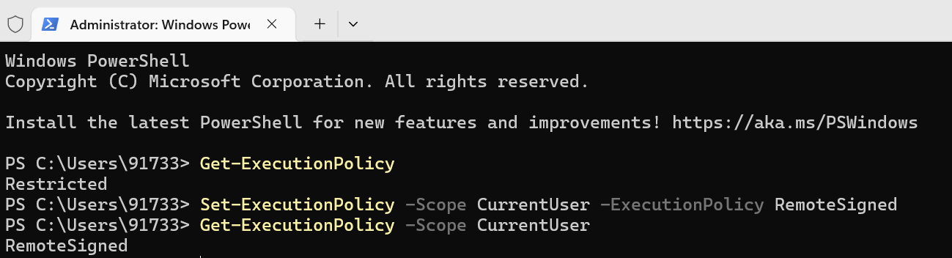
- Retry npm install from visual studio terminal :
npm install -g typescript
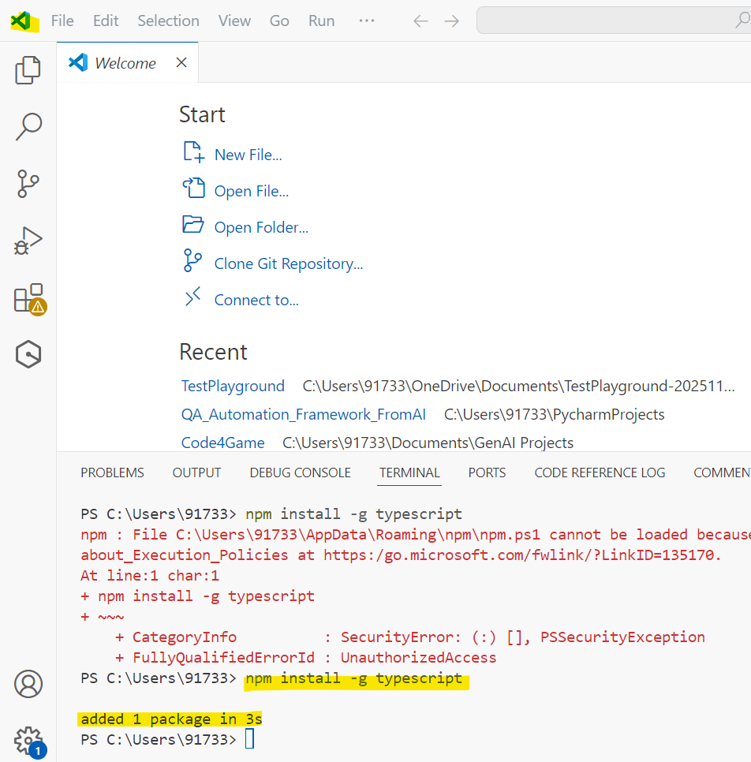

Create new folder in FileSystem anywhere in your drive and Open this folder from Visual Studio Code
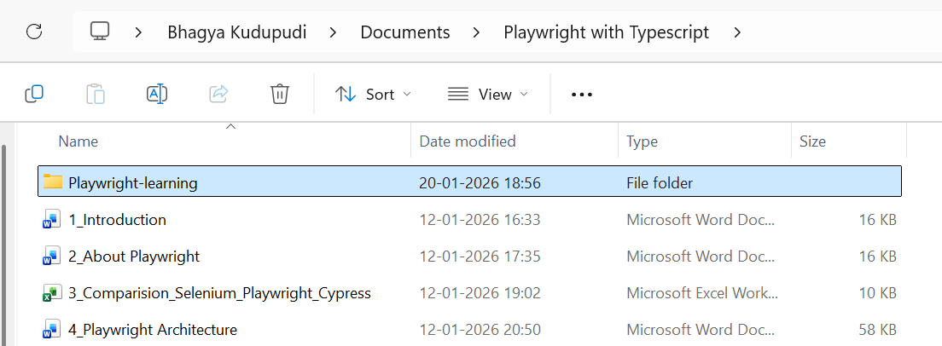
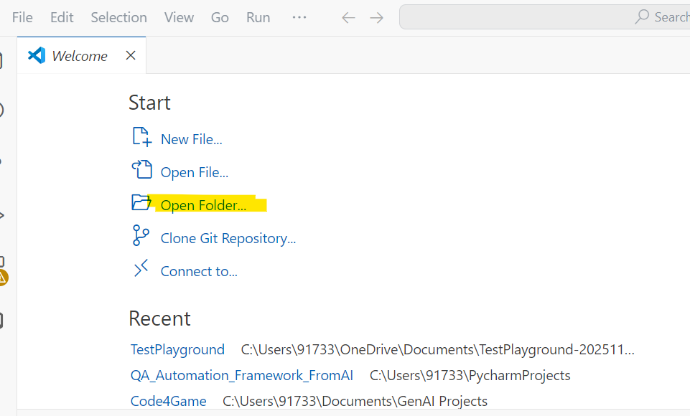
Select Folder
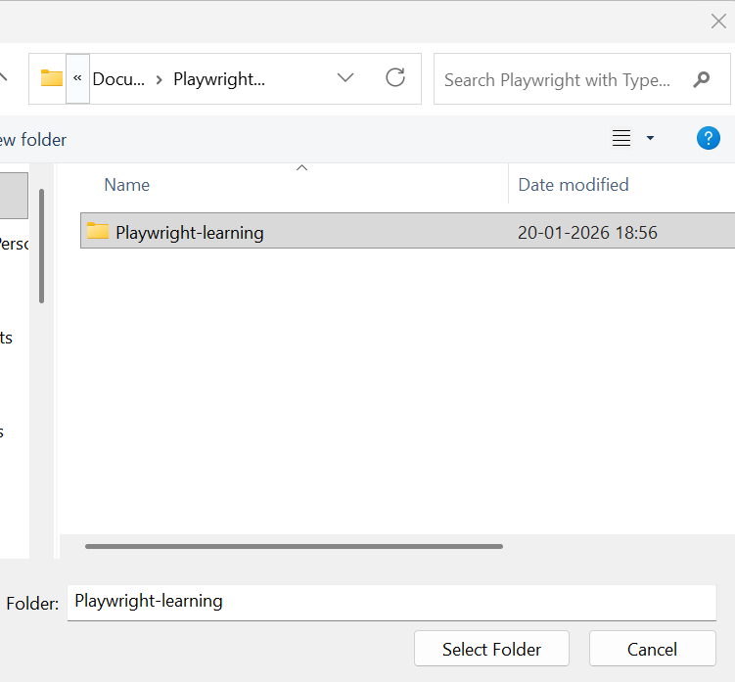
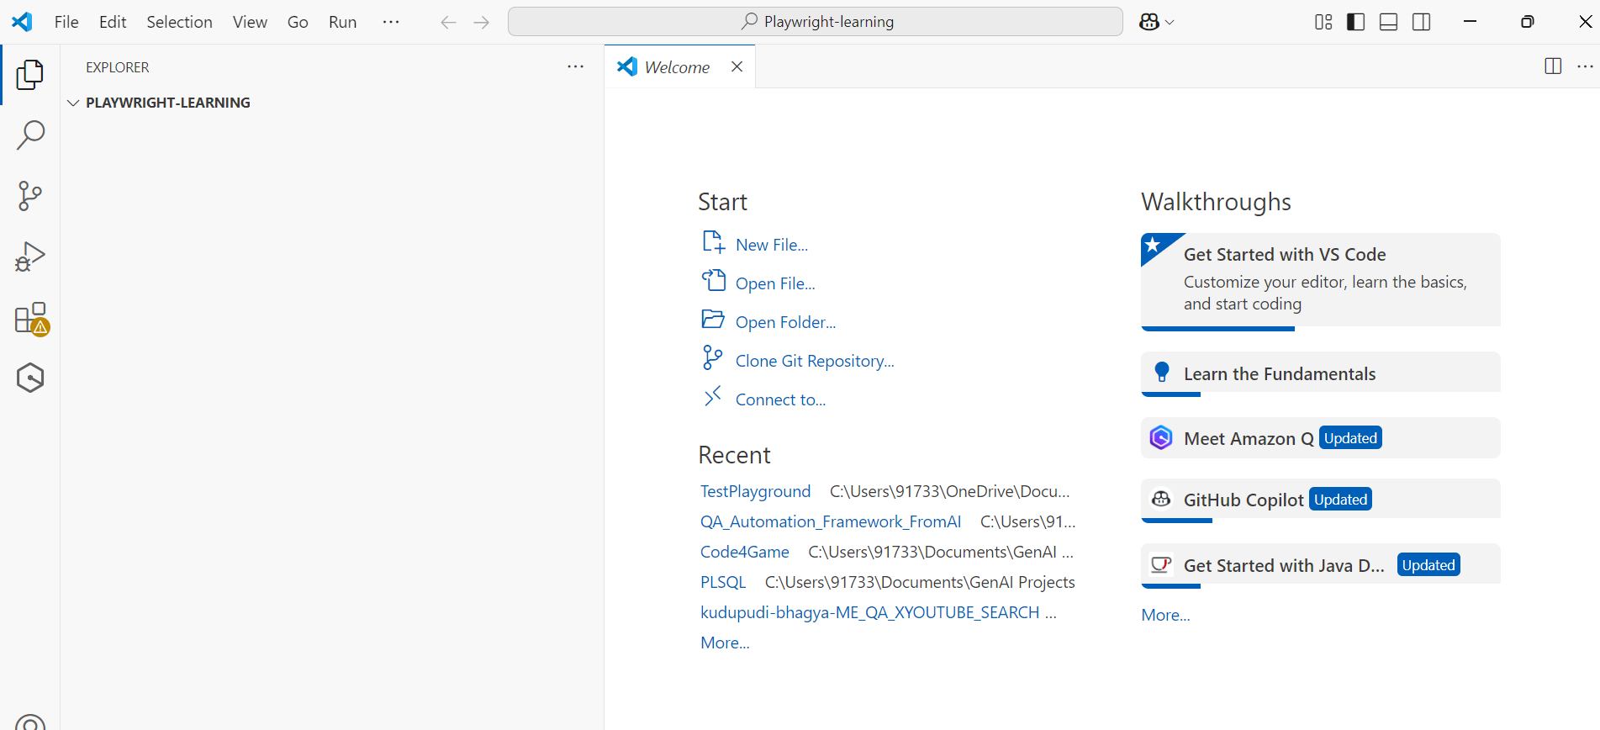

Some more initializations to be done

Create package.json file
View > Terminal
npm init -y
This creates a package.json file inside the folder
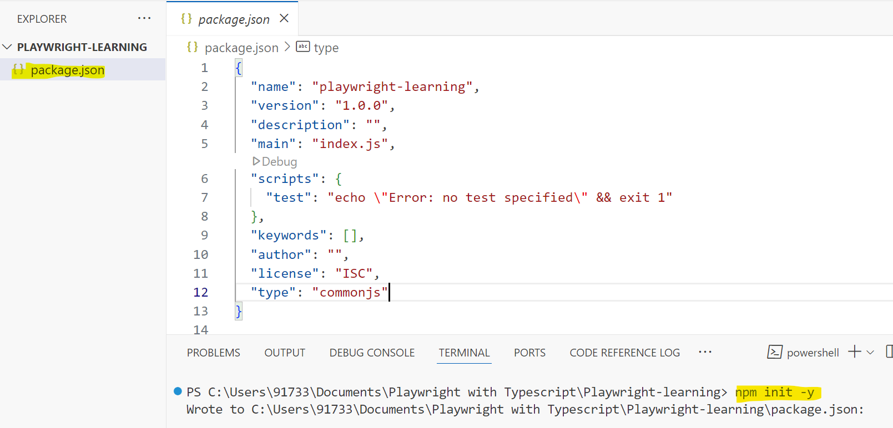

We write all the dependencies in this package.json file.

Install ts config file in the form of json file
View > Terminal
tsc --init
This creates a tsconfig.json file inside the folder
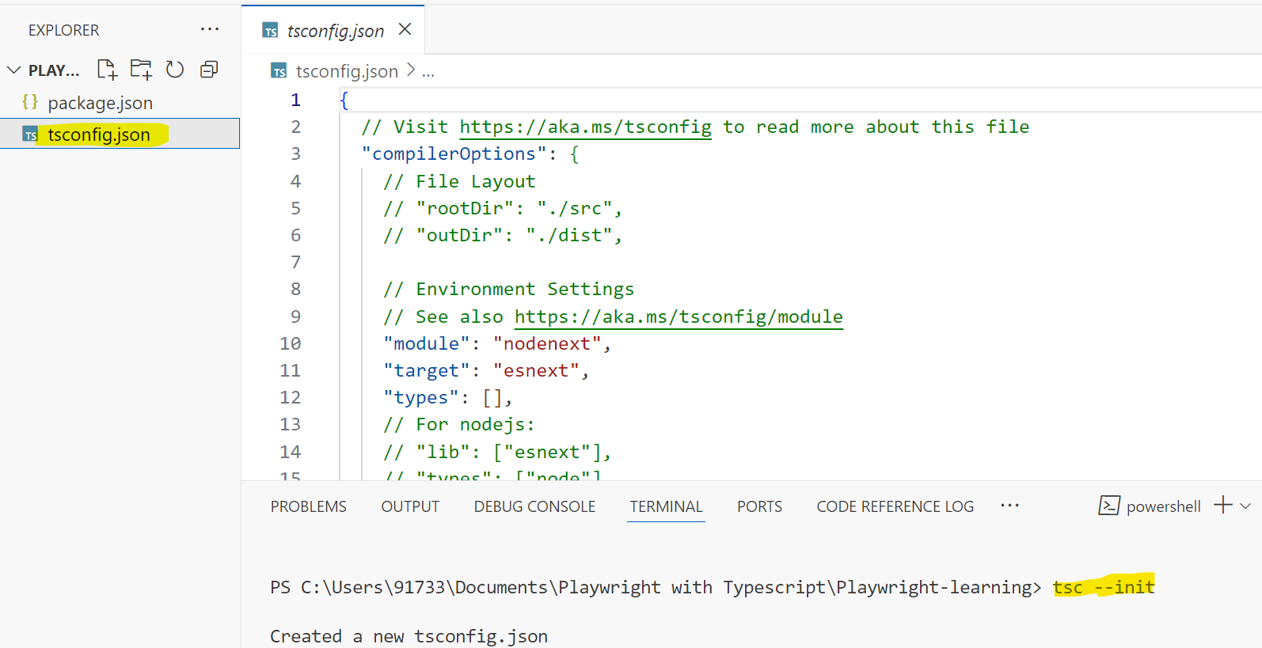
Remove the existing content in the tsconfig file and add below content:

{
"compilerOptions": {
"target": "es2016",
"module": "commonjs",
"rootDir": "./src",
"outDir": "./dist",
"strict": true
},
"include": ["src"]
}

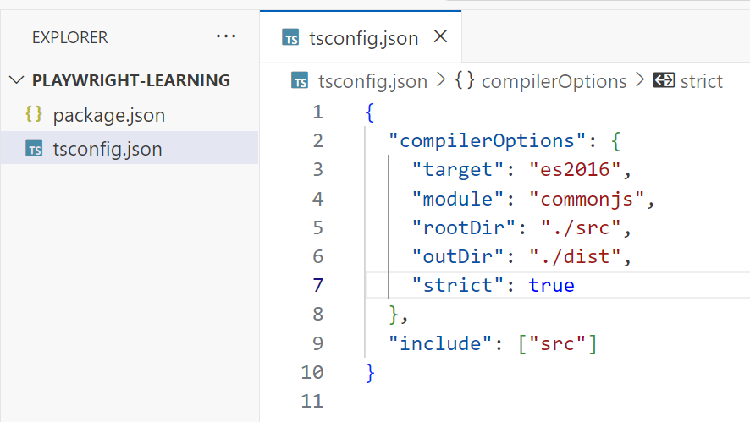

Create src and dist folder inside PLAYWRIGHT-LEARNING folder
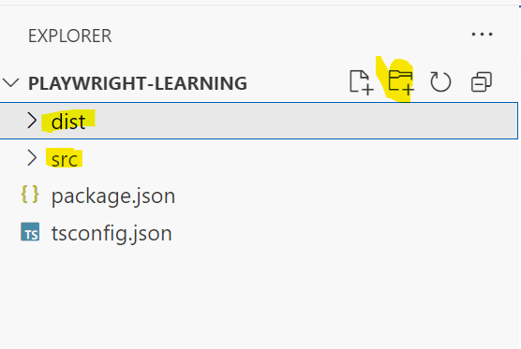
We create typescript files (.ts) inside src folder. Create intro.ts file inside the src folder with the code discussed above
function add(a:number,b:number){
return a+b;
}
let sum=add(2,3);
console.log(sum);

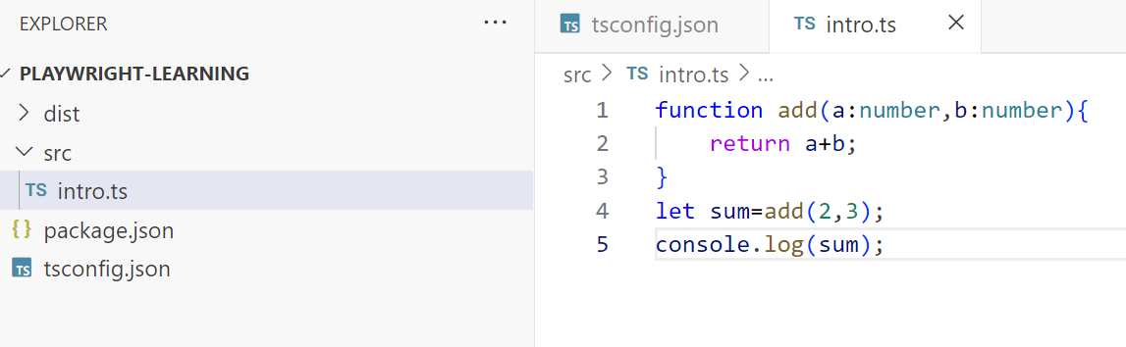

Steps to execute typescript code

Compile the .ts file in src folder
VS Code > View > terminal
npx tsc
- npx
A command-line tool that comes with Node.js (since version 5.2 of npm).
It lets you run executables (binaries) from npm packages without installing them globally.
- tsc
Short for TypeScript Compiler.
It’s the command-line tool that compiles .ts (TypeScript) files into .js (JavaScript).
This command will compile all the typescript files and generate .js file.
As we have given "outDir": "./dist" in tsconfig.json, .js file gets saved inside dist folder.
We are not going to directly execute the typescript file. We are going to execute .js file generated in the dist folder.
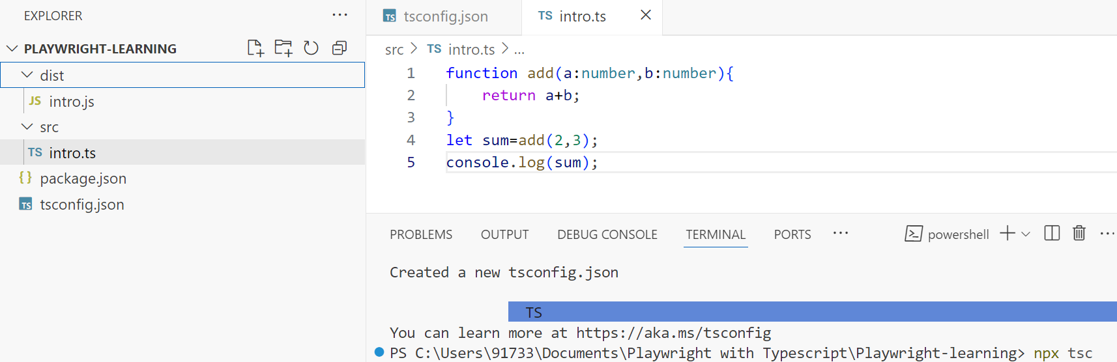

Execute the .js file inside dist folder
node .\dist\<<filename.js>>
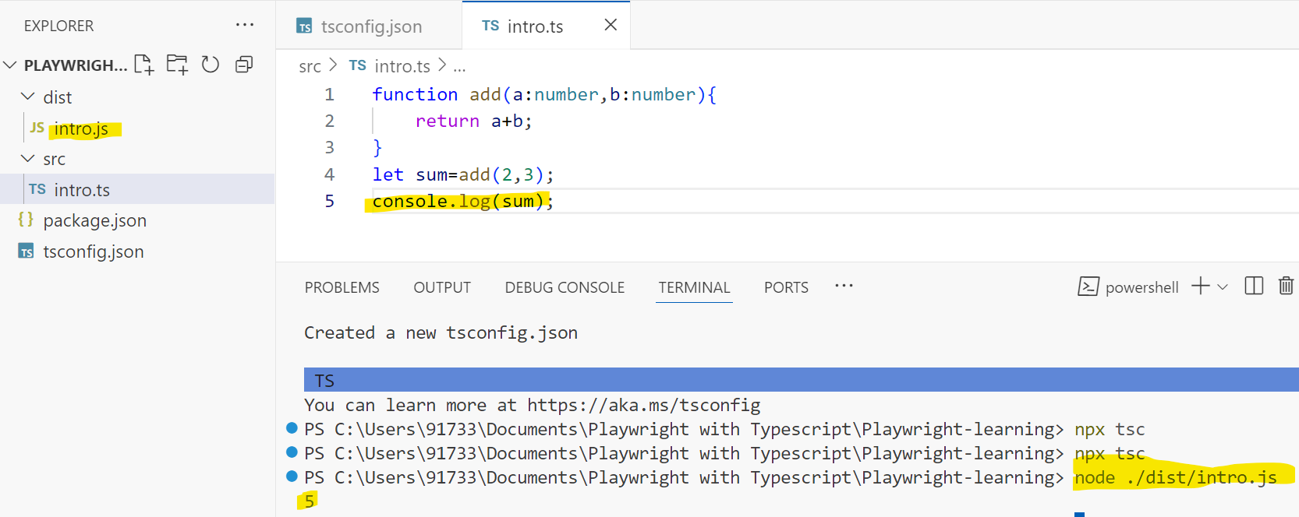

Install CodeRunner plugin
Extensions tab > Code Runner > Install
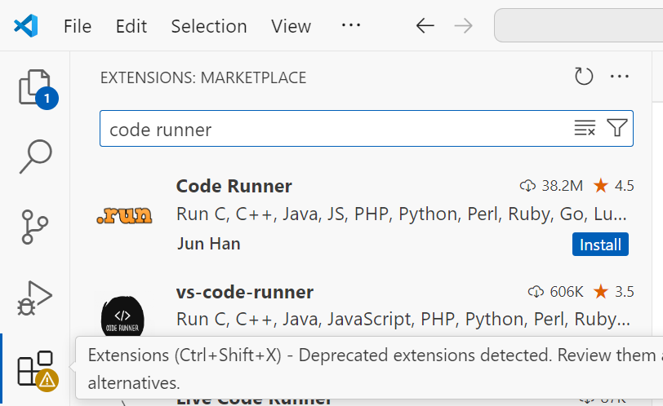
Code Runner is used to execute the .ts file directly without first compiling to .js and then running.
When you right-click on a .ts file in VS Code, you’ll see the “Run Code” option provided by the Code Runner extension.
Code Runner is basically the shortcut / UI layer that invokes ts-node for you

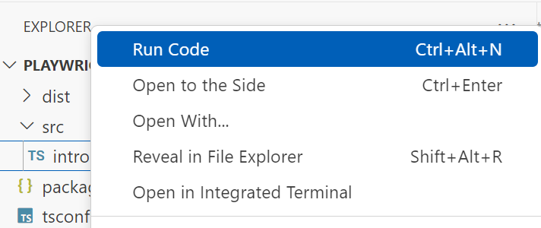
Click on ‘Run Code’ and the .ts file gets executed.
Error:
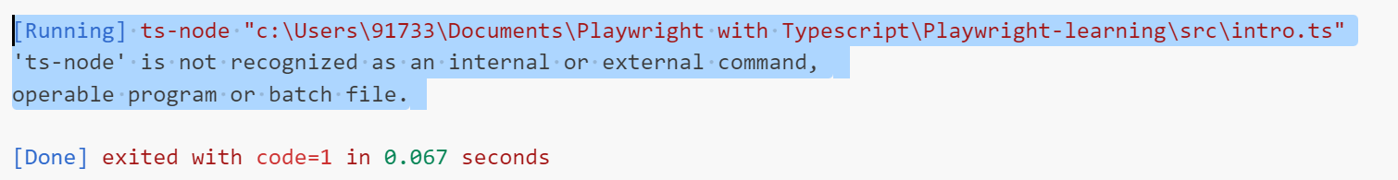
✅ Steps to Resolve

Install ts-node
Install ts-node globally: ts-node lets you run .ts files directly without compiling them first.
npm install -g ts-node
Now retry running code using Run Code option:
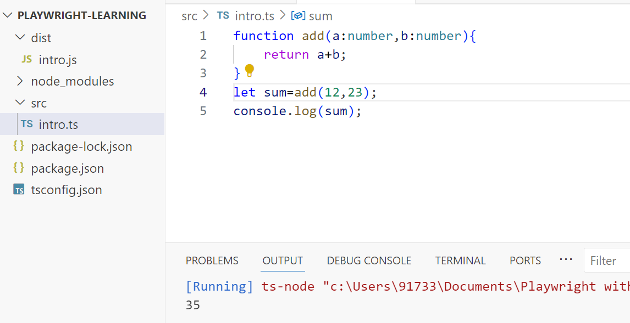

ts-node is the actual tool that makes it possible to run a .ts file directly. It compiles the TypeScript in memory and executes it with Node.js, so you don’t need the intermediate .js file.
Code Runner is just the VS Code extension that provides the Run Code button and context menu. It doesn’t know how to run TypeScript itself — instead, it delegates the job to whatever command you configure (commonly ts-node)

Command to run from terminal using ts-node
In case we want to run the .ts file from terminal using ts-node, we need to give below command:
npx ts-node src\intro.ts
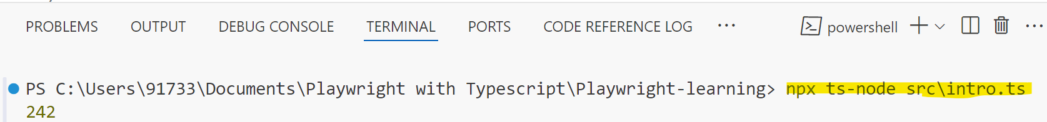

Naming Convention
file name - intro-to-ts.ts
class name - LoginTest
function name - calculateSum
variable name - userAge
constant name - NO_OF_USERS

Variables
Containers to store data. We use let, const, var. var is not frequently used in type script (legacy code).
In typescript we can define variables, with or without data type.
let age:number=30;
let firstName:string="John";
let isActive:boolean=false;
let city="Delhi"; //automatically treats city as string
//city=123; //error - as typescript does not allow changing type

const AGE=23;
//AGE=45; //error - cannot reassign a constant variable

const PERSON={"name":"Alice","age":30};
PERSON.age=31; //allowed - as we are not reassigning PERSON but changing its value
//PERSON={"name":"Bob","age":40}; //error - cannot reassign a constant variable

Data Types

Common Types

string
- can be defined using single or double quotes –
"hello" or 'hello'

boolean - true/false

number - integer, float, negative numbers
let d:number=12.34;
d=56;
d=-78.9;

special types in TypeScript

any
- can hold any type of value - but it defeats the purpose of TypeScript as typescript is type safe
let a: any="hello";
a=123;
a=true;
console.log(a.toUpperCase());//allows but may cause runtime error if a is not string

unknown
- similar to any but safer to use
let b:unknown="hello";
b=123;
b=true;
b="hello world";
//console.log(b.toUpperCase()); //compile time error - as typescript does not know the type of b at this point
if(typeof b==="string"){
console.log(b.toUpperCase());
}

More Types

Union Type - variable can hold more than one type
let c:string|number;
c="hello";
c=123;

Array - collection of values of same type
//We can define array using two ways
//one way
let fruits:string[]=["apple","banana"];
let numbers:number[]=[1,2,3];
//second way
let names:Array<string>=["Alice","Bob"];

Tuple - fixed size array with specific types at each index
let person:[string,number,string]=["Alice",30,"Engineer"];

enum - to define a set of named constants
enum Direction{
Up,
Down,
Left,
Right
}
let move:Direction=Direction.Up;

Object - collection of key-value pairs
let student:{rollNo:number,name:string,isActive:boolean}={
rollNo:101,
name:"Alice",
isActive:true
}

==, ==, ===
/*
= assignment operator
== compares values 1=="10" - true
=== compares values and types 1==="10" - false
*/

Operators
Operators in TypeScript are used to perform operations on variables and values.
TypeScript supports various types of operators, including arithmetic, comparison, logical, assignment, and more. Here are some examples:

Arithmetic Operators - +, -, *, /, %
let a1:number=10;
let b1:number=3;
console.log(a1+b1); //13
console.log(a1-b1); //7
console.log(a1/b1); //3.3333
console.log(a1*b1); //30
console.log(a1%b1); //1

Comparison(Relational) Operators - ==, !=, >, <, >=, <=
console.log(a1==b1); //false
console.log(a1!=b1); //true
console.log(a1>b1); //true
console.log(a1<b1); //false

const f1:number=5;
const f2:number=10;
console.log(f1!==f2); //true
console.log((5 as number)!=(6 as number)); //true
//console.log(5!=6);
//give compile time error if we do not specify type as number.
// However,this is allowed in JavaScript. TypeScript enforces type safety.

Logical Operators - &&, ||, !
let isAdult:boolean=true;
let hasLicense:boolean=false;
console.log(isAdult && hasLicense); //false
console.log(isAdult || hasLicense); //true
console.log(!isAdult); //false

Assignment Operators - =, +=, -=, *=, /=
a1=12;
a1+=3; //a1=a1+3 -> 13
a1-=2; //a1=a1-2 -> 11
a1*=2; //a1=a1*2 -> 22
a1/=3; //a1=a1/3 -> 7.3333
console.log(a1); //7.3333

Unary Operators - single operand - ++, --, -,!
let count: number=10;
console.log(++count); //11
console.log(count++); //11
console.log(count); //12
console.log(--count); //11
console.log(count--); //11
console.log(-count); //-10
console.log(!(5>3)); //false

Ternary Operator - condition ? expr1 : expr2
let age1:number=20;
let canVote:string=(age1>=18)?"Adult":"Minor";
console.log(canVote);

Type Operator - as, typeof, instanceof

Usage of 'as' operator with ‘any’ type
- any means “I don’t care about type safety.”
- You can call methods directly without as, but if you want to help the compiler (or yourself) you can use as.
Example:
let msg:any="Hello TypeScript";// Works even without 'as' (unsafe):
console.log(msg.toUpperCase()); // With 'as' (compiler now treats it as string):
console.log((msg as string).toUpperCase());
👉 Here, as is optional because any already lets you do anything.
But using as makes your intent clearer and helps with autocomplete/intellisense.

Usage of 'as' operator with ‘unknown’ type
- unknown means “I don’t know the type yet, prove it before using.”
- You cannot call methods directly. You must narrow or assert with as.

let value: unknown = "hello";
//console.log(value.toUpperCase());//Error: Object is of type 'unknown'
console.log((value as string).toUpperCase());//Must assert first using as

👉 Here, as is mandatory if you want to use the value without type guards.
It’s the safe alternative to any because the compiler forces you to be explicit.
Type guards are runtime checks that let TypeScript narrow down the type of a variable within a certain block of code.
They answer the question: “Is this value really of type X?”
Common Type Guards
1. typeof()
Used for primitive types (string, number, boolean, symbol, bigint, undefined).
2. instanceof()
Used for class instances.

typeof operator - to get the type of a variable at runtime
let sampleNumber:number=42;
console.log(typeof sampleNumber); // "number"

instanceof - check if an object is instance of class or interface
let date=new Date();
console.log(date instanceof Date); //true

Concatenation Operator - +
let part1: string="Hello, ";
let part2: string="TypeScript!";
let part3: string=" I love coding.";
console.log(part1+part2+part3); // "Hello, TypeScript! I love coding."
console.log(10+20+part1+part2); //"30Hello, TypeScript!"
console.log(part1+(10+20)+part2); //"Hello, 30TypeScript!"

Functions

Function with no return type
function printHello():void{
console.log("hello")
}
printHello();

Function with parameters
function log(msg:string):void{
console.log(`Printing message: ${msg}`)
}
log("I love coding");

Function with a return type
function sumOf2(a:number,b:number):number{
return a+b;
}
console.log(sumOf2(12,43));

function greet(name:string):string{
return `hello ${name}`;
}
console.log(greet("bhagya"));

Optional Parameter
Use ? to make a parameter as optional.
function welcome(name:string,age?:number):string{
return age?`Hello, ${name} with age as ${age}`:`Hello, ${name}`;
}
console.log(welcome("bhagya",34));
console.log(welcome("jaasri"))

Arrow function
//arrow function
const multiplyArrow=(a:number,b:number):number => a*b;
console.log(multiplyArrow(23,6));

Function Overloading
function combine(a:number,b:number):number;
function combine(a:string,b:string):string;
function combine(a:number,b:number,c:string):string;
function combine(a:any,b:any,c?:any):any{
if(typeof a === "number" && typeof b=== "number"&& typeof c==="string"){
return (a+b).toString()+c;
}
else if(typeof a === "string" && typeof b=== "string"){
return a+b;
}
else if(typeof a === "number" && typeof b=== "number"){
return (a+b);
}
}
console.log(combine(2,3,"hello"))
console.log(combine("hello"," world"))
console.log(combine(2,3))

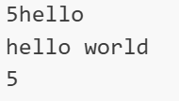

Random Number Generation
Math.random() generates a random decimal number between 0 (inclusive) and 1 (exclusive).
max number is 0.9999999,min number is 0

Math.random()*4 = generates a random decimal number between 0 (inclusive) and 4 (exclusive).
Ex:
Math.random() = 0.123456789
Math.random()*4 = 0.493827156
Math.floor() rounds a decimal number down to the nearest whole number.
Ex:
Math.floor(0.493827156) = 0
Math.floor(3.9999999) = 3

const randomNum = Math.random()*5;
console.log(randomNum);
//generates a random decimal number between 0 (inclusive) and 5 (exclusive).
// Min number is 0 ,Max number is 4.9999999

const randomInt = Math.floor(randomNum);
console.log(randomInt);
//generates a random integer between 0 (inclusive) and 4 (inclusive).
// Min number is 0 ,Max number is 4

Control Flow Statements

if-else if-else syntax
/*
if(condition){
//code to execute if condition is true
} else if(anotherCondition){
//code to execute if anotherCondition is true
} else{
//code to execute if all conditions are false
}
*/
const randomNumber=Math.floor(Math.random()*10);
console.log(`Random number between 0 and 9: ${randomNumber}`);
if(randomNumber<5){
console.log("The number is less than 5");
}
else if(randomNumber===5){
console.log("The number is equal to 5");
}
else{
console.log("The number is greater than 5");
}

switch
/*
switch(expression){
case value1:
//code to execute if expression matches value1
break;
*/

const randomValue = Math.floor(Math.random()*5);
switch(randomValue){
case 0:
console.log("The value is ZERO:" + randomValue);
break;
case 1:
console.log("The value is ONE:" + randomValue);
break;
case 2:
console.log("The value is TWO:" + randomValue);
break;
case 3:
console.log("The value is THREE:" + randomValue);
break;
case 4:
console.log("The value is FOUR:" + randomValue);
break;
}

Loops
/*
Loops: way to repeat a block of code multiple times
Types of loops:
for
while
do while
nested loops
for each
*/

while
let count1=1;
while(count1<=10){
console.log(count1);
count1++;
}

do-while
console.log("Using do-while loop");
do{
console.log(count1);
count1++;
}while(count1<=10);

for
console.log("Using for loop");
for(let count2=1;count2<=10;count2++){
console.log(count2);
}

/*
while: when you don't know how many times the loop will run, it will run until the condition becomes false
do-while: similar to while loop but it will execute the block of code at least once, even if the condition is false
for: when you know how many times the loop will run, it consists of three parts: initialization, condition and increment/decrement
nested loops: a loop inside another loop
for each: used to iterate over arrays or collections, it executes a block of code for each element in the array or collection
*/

Nested loops
console.log("Using nested loops");
for(let i=1;i<=2;i++){
for(let j=1;j<=3;j++){
console.log(`i:${i}, j:${j}`);
}
}
//i:1, j:1
//i:1, j:2
//i:1, j:3
//i:2, j:1
//i:2, j:2
//i:2, j:3

let numA=1;
while(numA<2){
for(let numB=1;numB<=3;numB++){
let numC=1;
do{
console.log(`numA:${numA}, numB:${numB}, numC:${numC}`);
numC++;
}while(numC<=4);
}
numA++;
}

/*
numA:1, numB:1, numC:1
numA:1, numB:1, numC:2
numA:1, numB:1, numC:3
numA:1, numB:1, numC:4
numA:1, numB:2, numC:1
numA:1, numB:2, numC:2
numA:1, numB:2, numC:3
numA:1, numB:2, numC:4
numA:1, numB:3, numC:1
numA:1, numB:3, numC:2
numA:1, numB:3, numC:3
numA:1, numB:3, numC:4
*/

forEach
console.log("Using forEach loop");
const fruitNames=["apple","banana","orange"];
fruitNames.forEach((fru)=>{
console.log("I like: " + fru);
})

//we can also use forEach loop with index
fruitNames.forEach((fru,index)=>{
console.log(`I like: ${fru} at index ${index}`);
})

Arrays
/*
Array stores multiple values in a single variable.
It is a data structure that can hold a fixed number of values of the same type.
Each value in an array is called an element,and each element is identified by its index, which starts at 0.
The length of an array is the number of elements it contains.
*/

var rollNos:number[]=[11,22,33,44,55];
for(let index=0;index<rollNos.length;index++){
console.log(rollNos[index]);
}

console.log("5 random values between 0(inclusive) and 100(exclusive):");
const randomValues:number[]=new Array(5);
//Using for loop to generate 5 random values between 0 (inclusive) and 100 (exclusive) and store them in the array
for(let index=0;index<randomValues.length;index++){
randomValues[index]=Math.floor(Math.random()*100);
console.log(randomValues[index]);
}

//Using forEach loop to iterate over the array and print the values
console.log("Using forEach loop to print the random values:");
randomValues.forEach((value,index)=>
{
console.log("values of number at index " +index + " is: " + value)
})

//Using for with of loop to iterate over the array and print the values
console.log("Using for with of loop to print the random values:");
for(let rv of randomValues){
console.log(rv);
}

console.log("Printing the random values in reverse order:");
for(let index=randomValues.length-1;index>=0;index--){
console.log(randomValues[index]);
}

2D Array
const arr:number[][] = [
[20,45,12],
[25,90,56]
]

console.log(arr[1][1]); //90

console.log("No. of rows in this 2d array: ",arr.length);

for(let row=0;row<arr.length;row++){
for(let col=0;col<arr[row].length;col++){
console.log(arr[row][col]);
}
console.log("End of row " + row);
}

Tuples
/*
Tuple is a data structure that can hold a fixed number of values of different data types.
Unlike arrays that allows multiple values of same datatype, tuples can hold values of different data types.
tuples let you define exact type and number of elements.
*/

console.log("Using tuples in TypeScript");
let employee:[number,string,boolean]=[1,"bhagya",true];
console.log(employee[0]);

console.log();

tuple with optional elements
console.log("tuple with optional elements");
let studentDetails:[number,string,boolean?]=[101,"jaasri"];
console.log(studentDetails[0]);
console.log(studentDetails[1]);
console.log();

tuples with spread operator
console.log("tuples with spread operator");
let empDetails:[string,number,...string[]]=["sahitya",103,"developer","tester","manager"];
console.log(empDetails[4]); //manager
console.log();

merge 2 tuples
console.log("merging 2 tuples");
let tuple1:[number,string]=[1,"bhagya"];
let tuple2:[boolean,string]=[true,"developer"];
let mergedTuple=[...tuple1,...tuple2];
console.log(mergedTuple); //[1, "bhagya", true, "developer"]

Objects
Objects allow you to store and organize data in key-value pairs.
Objects can also include methods, which are functions that operate on the data within the object.
Objects are created using curly braces {} and properties are defined using key-value pairs.
key is always a string and value can be of any data type, including another object or a function.
You can access the properties of an object using dot notation or bracket notation.
You can also add, update or delete properties of an object.
*/

//Creating an object
let personA={
name:"bhagya",
age:34,
isStudent:true,
hobbies:["coding","reading","traveling"],
address:{
street:"123 Main St",
city:"Hyderabad",
country:"India"
}
}

console.log(personA.name); //bhagya
console.log(personA["age"]); //34
console.log(personA.hobbies[0]); //coding
console.log(personA.address.city); //Hyderabad

Creating an object by defining type as well
console.log();
console.log("Creating an object by defining type as well");
const personB:{
name :string,
age:number,
isStudent:boolean,
}={
name:"jaasri",
age:28,
isStudent:false
};

console.log(personB.name); //jaasri

Objects
>Objects allow you to store and organize data in key-value pairs.
>Objects can also include methods, which are functions that operate on the data within the object.
>Objects are created using curly braces {} and properties are defined using key-value pairs.
>key is always a string and value can be of any data type, including another object or a function.
>You can access the properties of an object using dot notation or bracket notation.
>You can also add, update or delete properties of an object.
*/

Creating an object
let personA={
name:"bhagya",
age:34,
isStudent:true,
hobbies:["coding","reading","traveling"],
address:{
street:"123 Main St",
city:"Hyderabad",
country:"India"
}
}

console.log(personA.name); //bhagya
console.log(personA["age"]); //34
console.log(personA.hobbies[0]); //coding
console.log(personA.address.city); //Hyderabad

Creating an object by defining type as well
console.log();
console.log("Creating an object by defining type as well");
const personB:{
name :string,
age:number,
isStudent:boolean,
}={
name:"jaasri",
age:28,
isStudent:false
}

console.log(personB.name + " of type: " + typeof personB.name); //jaasri

Object with methods
let car={
make:"Toyota",
speed:200,
drive():string{
return "The car is driving fast at " + this.speed + " km/h";
}
}
console.log(car.drive()); //The car is driving fast at 200 km/h

console.log();

merge 2 objects using spread operator
console.log("Merging 2 objects using spread operator");
let obj1={name:"Alice",age:30};
let obj2={city:"New York",country:"USA"};
let mergeObj={...obj1,...obj2};
console.log(mergeObj); //{name: "Alice", age: 30, city: "New York", country: "USA"}
console.log(mergeObj.name); //Alice

OOPS: Class and Object
/*
>Class is a blueprint of an Object.
>It defines the properties and methods that an object can have.
>An object is an instance of a class.
>It is created using the new keyword and can access the properties and methods defined in the class.
>Classes can also have constructors, which are special methods that are called when an object is created.
>Constructors are used to initialize the properties of an object.
*/

class Person{
//instance variables
name:string;
id:number;

constructor(name:string,id:number){
this.name=name;
this.id=id;
}

greet():string{
return `Hello,${this.name}, your id is ${this.id}`;
}
add(a:number,b:number):number{
return a+b;
}
}

const per=new Person("kiran",90);
console.log(per.name); //kiran
console.log(per.id);
console.log(per.greet()); //Hello,kiran, your id is 90

per.name="kkkkk";
per.id=100;
console.log(per.name); //kkkkk
console.log(per.greet()); //Hello,kkkkk, your id is 90

console.log(per.add(12,34)); //46

OOPs: Access Modifiers and Variable scope
class Employee_Details{
public emp_id:number;//instance variable can be accessed using the object of the class
private emp_name:string;//private variable can be accessed only within the class
protected emp_salary:number;
static message:string="Welcome to the company";//static variable belongs to the class and can be accessed without creating an instance of the class

constructor(emp_id:number,emp_name:string,emp_salary:number){
this.emp_id=emp_id;
this.emp_name=emp_name;
this.emp_salary=emp_salary;
}

getSalaryDetails():string{
var department:string="IT";//local variable can be accessed only within the method
return `${this.emp_name} has a salary of ${this.emp_salary} and department is ${department}`;
}
}

const emp1=new Employee_Details(101,"bhagya",5000000);
console.log(emp1.emp_id); //101 - public variable can be accessed outside class using the object of the class
//console.log(emp1.emp_name); //error - private variable can be accessed only within the class
//console.log(emp1.emp_salary); //error - protected variable can be accessed only within the class and its subclasses
console.log(Employee_Details.message); //Welcome to the company - static variable can be accessed without creating an instance of the class and using the class name
console.log(emp1.getSalaryDetails()); //bhagya has a salary of 5000000

Export and Import
>export and import are used to share code between different files in TypeScript.
>export is used to export a variable, function, class or interface from a file so that it can be imported in another file.
>import is used to import the exported variable, function, class or interface from another file.

export

export var something:number=12;

export function addition(a:number,b:number):number{
return a+b;
}

export class Employee_Details{
public emp_id:number;//instance variable can be accessed using the object of the class
private emp_name:string;//private variable can be accessed only within the class
protected emp_salary:number;

static message:string="Welcome to the company";//static variable belongs to the class and can be accessed without creating an instance of the class

constructor(emp_id:number,emp_name:string,emp_salary:number){

this.emp_id=emp_id;
this.emp_name=emp_name;
this.emp_salary=emp_salary;

}

getSalaryDetails():string{
var department:string="IT";//local variable can be accessed only within the method
return `${this.emp_name} has a salary of ${this.emp_salary} and department is ${department}`;
}
}

------------------------------------

import
import {Employee_Details,addition,something} from "./16_export";

const emp1=new Employee_Details(101,"bhagya",5000000);
console.log(emp1.emp_id);
console.log(Employee_Details.message); //Welcome to the company - static variable can be accessed without creating an instance of the class and using the class name
console.log(emp1.getSalaryDetails()); //bhagya has a salary of 5000000

console.log(addition(12,45))
console.log(something); //12

OOPs: Inheritance
class WebDriver{
url:string;

constructor(url:string){
this.url=url;
}

navigate():void{
console.log(`Navigating to ${this.url}`);
}
}

class ChromeDriver extends WebDriver{
constructor(url:string){
super(url);
}

lauchBrowser():void{
console.log("Launching Chrome Browser");

}
}

class FirefoxDriver extends WebDriver{
constructor(url:string){
super(url);
}

lauchBrowser():void{
console.log("Launching Firefox Browser");
}

}

var chrome=new ChromeDriver("https://www.google.com");
chrome.lauchBrowser(); //Launching Chrome Browser
chrome.navigate();

var firefox=new FirefoxDriver("https://www.redbus.com");
firefox.lauchBrowser(); //Launching Firefox Browser
firefox.navigate();

Output

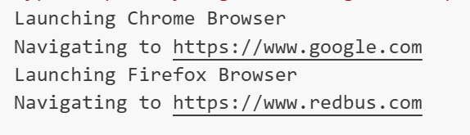

OOPs: Abstract Class
//If a class is marked as abstract, it cannot be instantiated directly and must be subclassed.
//Abstract classes can contain both abstract and non-abstract methods.
//Abstract methods are declared without an implementation and must be implemented by the subclasses.
//Non-abstract methods can have an implementation in the abstract class and can be inherited by the subclasses.

abstract class WD{
url:string;

constructor(url:string){
this.url=url;
}

navigate():void{
console.log(`Navigating to ${this.url}`);
}
abstract launchBrowser():void;//abstract method does not have a body and must be implemented by the subclasses
}

class CD extends WD{
constructor(url:string){
super(url);
}

launchBrowser():void{
console.log("Launching Chrome Browser");
}
}

class FD extends WD{
constructor(url:string){
super(url);
}
launchBrowser():void{
console.log("Launching Firefox Browser");
}

}

var chrome1=new CD("https://www.google.com");
chrome1.launchBrowser();
chrome1.navigate();
var firefox1=new FD("https://www.redbus.com");
firefox1.launchBrowser();
firefox1.navigate();

OOPs: Interface
interface Webdriver{
browser:string
getTitle():string;
getUrl():string;
}

interface RemoteWebDriver {
launchBrowser():void;
}
class Chrome implements Webdriver,RemoteWebDriver{
launchBrowser(): void {
console.log("Launching Chrome Browser");
}
browser: string="Chrome Browser";
getTitle(): string {
return "Getting title of the page in "+this.browser;
}
getUrl(): string {
return "Getting url of the page in "+this.browser;
}

}

class Firefox implements Webdriver,RemoteWebDriver{
browser: string="Firefox Browser";
launchBrowser(): void {
console.log("Launching Firefox Browser");
}

getTitle(): string {
return "Getting title of the page in "+this.browser;
}
getUrl(): string {
return "Getting url of the page in "+this.browser;
}

}

const chrome2=new Chrome();
chrome2.launchBrowser();
console.log(chrome2.getTitle());
console.log(chrome2.getUrl());
const firefox2=new Firefox();
firefox2.launchBrowser();
console.log(firefox2.getTitle());
console.log(firefox2.getUrl());

OOPs: Getters and Setters
class emp{
private _salary:number=0;

get salary():number{
console.log("Getting salary details...");
return this._salary;
}

set salary(_salary:number){
if(_salary>0){
console.log(`Setting salary to ${_salary}...`);
this._salary=_salary;
}
else{
console.log("Salary must be greater than 0");
}
}
}

const empl1=new emp();
empl1.salary=5000000;//calls setter ,Setting salary details...
console.log(empl1.salary);//calls getter, Getting salary details... 5000000

/*
get salary() - getter method to access the private variable _salary.
It returns the value of _salary and also logs a message to the console.

set salary(_salary:number) - setter method to assign a value to the private variable _salary with some custom logic.
It takes a parameter _salary and checks if it is greater than 0.
If it is, it sets the value of _salary and logs a message to the console.
If it is not, it logs an error message to the console.

We don't call them as functions, we access them as properties of the object.
*/

Exception Handling
/*
try - block of code where exception might occur
catch - block of code where you handle the exception
finally - block of code that will always execute, regardless of whether an exception occurred or not
throw - used to throw an exception manually
*/

class ExceptionHandling{
static validateNumber(num:number):void{
if(num<0){
throw new Error("Negative number is not allowed");
}
}

static main():void{
try{
this.validateNumber(-5);
}
catch(error:any){
console.log("Validation error: " + error.message);
}
}
}

ExceptionHandling.main();
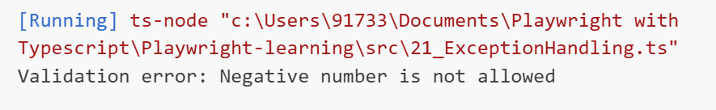
try{
var numbers:number[]=[1,2,3];
console.log(numbers[5].toString());
}
catch(e:any){
console.log("Array index error: " + e.message);
}

finally{
console.log("This block will always execute");
}

try{
const a:number=10;
const b:number=0;
const result=a/b;//gives infinity - In JS/TS division by zero does not throw an error, it returns Infinity

if(!isFinite(result)){
throw new Error("Division by zero is not allowed");

}
}
catch(e:any){
console.log("Math error: " + e.message);
}
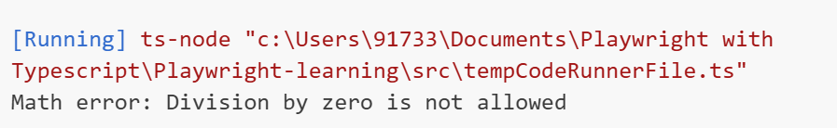

//Complete Code

class ExceptionHandling{
static validateNumber(num:number):void{
if(num<0){
throw new Error("Negative number is not allowed");
}
}

static main():void{
try{
this.validateNumber(-5);
}
catch(error:any){
console.log("Validation error: " + error.message);
}

try{
var numbers:number[]=[1,2,3];
console.log(numbers[5].toString());
}
catch(e:any){
console.log("Array index error: " + e.message);
}

finally{
console.log("This block will always execute");
}

try{
const a:number=10;
const b:number=0;
const result=a/b;//gives infinity - In JS/TS division by zero does not throw an error, it returns Infinity

if(!isFinite(result)){
throw new Error("Division by zero is not allowed");

}
}
catch(e:any){
console.log("Math error: " + e.message);
}
}
}

ExceptionHandling.main();

